

**Semester One**

**Examination 2018**

**Question/Answer booklet**

**MATHEMATICS**

**APPLICATIONS UNIT 1**

**Section Two:**

**Calculator-assumed**

|  |
| --- |
| Student Name: _____________________________________ |
| Teacher’s Name: _____________________________________ |

**Time allowed for this section**

Reading time before commencing work: ten minutes

Working time for paper: one hundred minutes

**Material required/recommended for this section**

**To be provided by the supervisor**

This Question/Answer booklet

Formula Sheet (retained from Section One)

**To be provided by the candidate**

Standard items: pens (blue/black preferred), pencils (including coloured), sharpener, correction tape/fluid, erasers, ruler, highlighters

Special Items: drawing instruments, templates, notes on two unfolded sheets of A4 paper, and up to three calculators approved for use in the WACE examinations.

**Important note to candidates**

No other items may be taken into the examination room. It is **your** responsibility to ensure that you do not have any unauthorised notes or other items of a non-personal nature in the examination room. If you have any unauthorised material with you, hand it to the supervisor **before** reading any further.

**Structure of this paper**

|  |  |  |  |  |  |
| --- | --- | --- | --- | --- | --- |
|  | Number of questions available | Number of questions to be attempted | Working time (minutes) | Marks available | Percentage of exam |
| Section One  Calculator—free | **6** | **6** | **50** | **50** | **35** |
| **Section Two**  **Calculator—assumed** | 14 | 14 | 100 | 100 | 65 |
|  | | | |  | 100 |

**Instructions to candidates**

1. The rules for the conduct of Western Australian external examinations are detailed in the

*Year 12 Information Handbook 2018.* Sitting this examination implies that you agree to abide by these rules.

1. Answer the questions according to the following instructions.

**Show all your working clearly.** Your working should be in sufficient detail to allow your

answers to be checked readily and for marks to be awarded for reasoning. Incorrect answers given without supporting reasoning cannot be allocated any marks. For any question or part question worth more than two marks, valid working or justification is required to receive full marks. If you repeat an answer to any question, ensure that you cancel the answer you do not wish to have marked.

It is recommended that you **do not use pencil**, except in diagrams.

1. You must be careful to confine your responses to the specific questions asked and to follow any instructions that are specific to a particular question.
2. Spare pages are included at the end of this booklet. They can be used for planning your responses and/or as additional space if required to continue an answer.

* Planning: If you use the spare pages for planning, indicate this clearly at the top of the page.
* Continuing an answer: If you need to use the space to continue an answer, indicate in the original answer space where the answer is continued, i.e. give the page number. Fill in the number of the question that you are continuing to answer at the top of the page.

1. The Formula Sheet is **not** handed in with your Question/Answer Booklet.

# Section Two: Calculator–assumed 65% (100 marks)

This section has **fourteen (14)** questions. Attempt **all** questions. Write your answers in the spaces

provided.

Spare pages are included at the end of this booklet. They can be used for planning your responses

and/or as additional space if required to continue an answer.

* Planning: If you use the spare pages for planning, indicate this clearly at the top of the page.
* Continuing an answer: If you need to use the space to continue an answer, indicate in the original answer space where the answer is continued, i.e. give the page number. Fill in the number of the question(s) that you are continuing to answer at the top of the page.

Working time: 100 minutes

**Question 7 (3 marks)**

The variables x and y are related by the formula 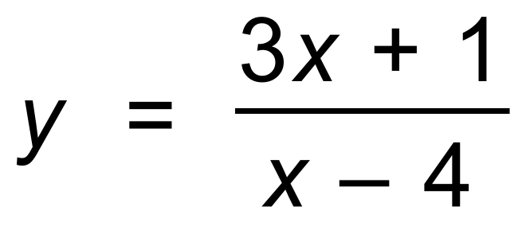 .

Determine:

(a) the value of y when x = 6. (1 mark)

(b) the value of y when x = 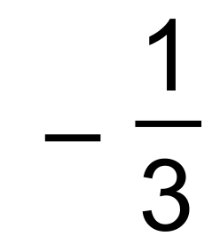 . (1 mark)

(c) the value of *x* when *y* = 7. (1 mark)

**Question 8 (9 marks)**

As at October 2017, the value of ten Australian dollars in foreign currencies is given in the table below.

|  |  |
| --- | --- |
| Foreign Currency | $10 Australian AUD |
| US dollars | $8 US |
| Malaysian Ringgit | 33.5 Ringgit |
| Balinese Rupiah | 105 000 Rupiah |

(a) State the value of $1 AUD in US dollars. (1 mark)

(b) How many Malaysian Ringgit could be purchased for $50 AUD? (1 mark)

Barry travels to Bali, after first visiting Malaysia. He has $1000 AUD, 1 000 000 Rupiah

and 2000 Ringgit with him.

(c) What is the total value of his currency in Australian dollars? (3 marks)

He exchanges the Ringgit for Rupiah.

(d) Use the Australian dollar conversion to find how many Rupiah he would receive. (2 marks)

A taxi to the airport will cost Barry 300 000 Rupiah. He has $30 AUD and 50 000 Rupiah in cash.

He gives it all to the driver.

(e) Show clearly that he has been generous to the taxi driver. (2 marks)

**Question 9 (6 marks)**

Erica’s new car cost her $30 000. She sold it three years later for $21 500.

(a) Determine the loss in dollars. (1 mark)

(b) Calculate the loss as a percentage of the cost price. (2 marks)

(c) Show how to use the formula 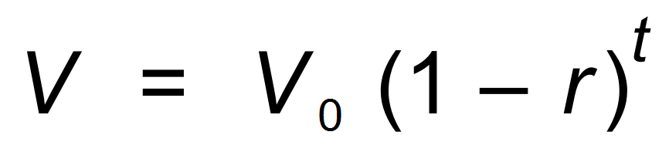, where *V* = value at time t years,

*V*0 = original value and r = rate of depreciation, to determine the rate of depreciation

per year. Give your answer as a number of % pa, correct to one decimal place. (3 marks)

**Question 10 (7 marks)**

Part of a Water Usage and Service Account is shown below.

Water Use: 10 483L at $1.158 per kL

Billing period: 63 days

(a) Determine the cost of the water used over this period. (2 marks)

The service account fee for this billing period is made up of a water supply charge and also a sewerage charge.

The water supply charge was $40.13

The **total** service account fee was $141.57

(b) Determine the sewerage charge. (1 mark)

(c) Calculate the **total** Water Usage and Service Account fee. (1 mark)

The total amount can be paid by credit card. A transaction fee of 0.48% applies.

(d) How much would the transaction fee be if this account is paid by credit card? (1 mark)

Interest is charged on overdue amounts at a rate of 11.88% pa. Assume there are 365 days in the year.

(e) Mary has an overdue bill of $227, and today it is 25 days overdue. If she pays it today, how much interest will she have to pay? (2 marks)

**Question 11 (7 marks)**

(a) Determine the value of x, correct to two decimal places, in each of the following triangles.

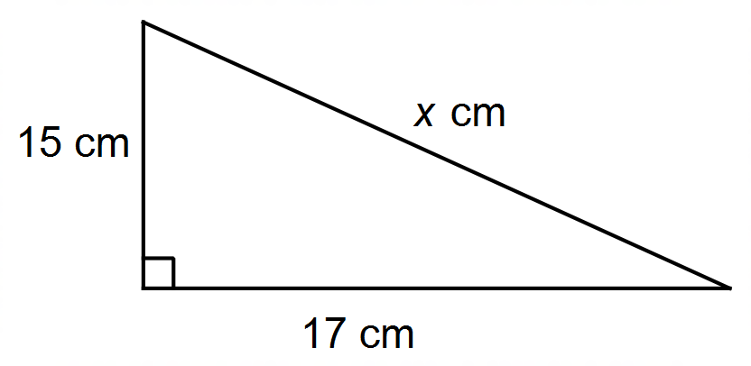

(i) (2 marks)

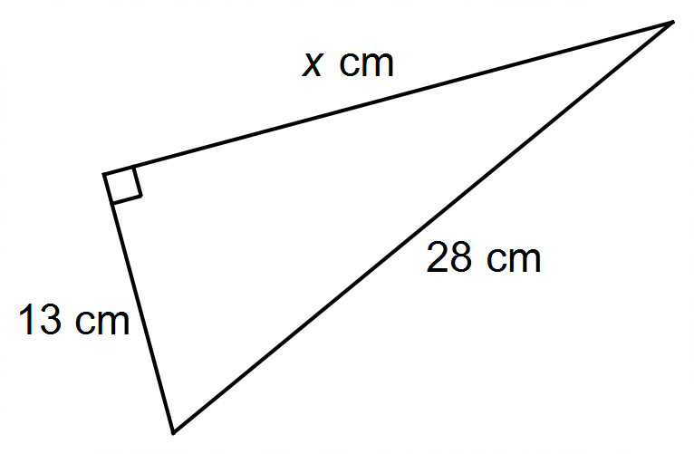

(ii) (2 marks)

(b) Old MacDonald had a farm, and on that farm he had a gate, as shown

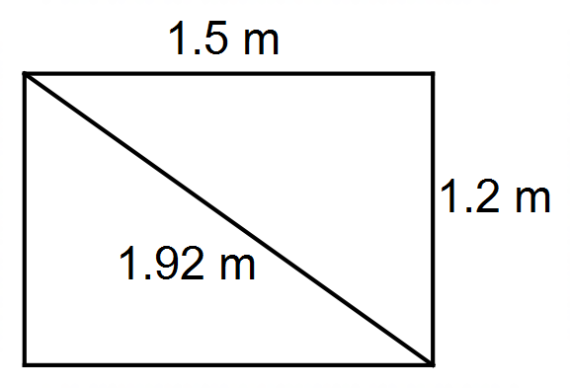

He measures the length, the width and the diagonal.

He wants to know whether the gate is “square”. That is, whether it is right-angled.

Use Pythagoras’ Theorem to determine whether the gate is “square”. (3 marks)

Assume his measurements are as **correct as his measuring tape will allow**.

**Question 12 (10 marks)**

The tax table for Australia for 2016−17 is shown below.

|  |  |
| --- | --- |
| Taxable Income | Tax on this Income |
| 0 − 18 200 | Nil |
| 18 201 − 37 000 | 19c for each dollar over $18 200 |
| 37 001 − 80 000 | $3572 plus 32.5c for each dollar over $37 000 |
| 80 001 − 180 000 | $17 547 plus 37c for each dollar over $80 000 |
| 180 001 and over | $54 547 plus 45c for each dollar over $180 000 |

(a) Nate has a taxable income of $25 000. What percentage of his income is paid in tax? (3 marks)

(b) Jenny has an annual income of $52 000. She has annual tax deductions of $4632.

On average, how much tax does Jenny need to pay per fortnight on this income? (3 marks)

(c) Justin paid $3572 in tax. What was his taxable income? (1 mark)

(d) Amber paid $600 in tax. What was her annual income? (3 marks)

**Question 13 (8 marks)**

Francine is offered a loan amount of $6000 to help finance an overseas trip.

She will repay that amount plus interest at the end of the three years.

She has a choice of:

Loan A − an interest rate of 6% pa simple (flat) interest.

Loan B − a rate of 5.5% pa compounded monthly.

(a) Which loan should she choose to repay a lesser amount? Justify your answer. (5 marks)

Francine invests some of the $6000 for two years prior to her departure overseas.

She receives 7% pa simple interest during that time, and has a final balance once

interest is added of $720.

(b) How much did she invest? (3 marks)

**Question 14 (8 marks)**

A garden nursery sells two types of home herb packs, labelled Home Herbs A and Home Herbs B.

Home Herbs A contains 3 punnets of coriander, 2 punnets of basil and 5 punnets of cumin.

Home Herbs B contains 6 punnets of coriander, 3 punnets of basil and 8 punnets of cumin.

(a) Write this as a 2 x 3 matrix called H. (1 mark)

The cost of each punnet of coriander, basil and cumin is $2, $3 and $4 respectively.

(b) Write this as a 3 x 1 matrix called C. (1 mark)

(c) Determine HC and interpret the information it represents. (2 marks)

The local garden centre purchases 30 packs of A and 40 packs of B.

(d) **Use matrix multiplication** to determine:

(i) the total number of punnets of each herb the garden centre has purchased. (2 marks)

(ii) the total cost to the garden centre. (2 marks)

**Question 15(7 marks)**

The table below shows the pay rates at Amanda’s work place.

There is no work on Saturday or Sunday.

|  |  |
| --- | --- |
| Day | Rate per Hour |
| Monday − Friday | $30 |
| Public Holiday | Time and a half |

Amanda works 8 hours per day when she works.

(a) Over the last month, Amanda worked on 19 normal days and on one Public Holiday.

Calculate Amanda’s income for this month. (2 marks)

(b) How many hours worked on a public holiday equate to a full day’s work on a

non−holiday workday? (2 marks)

(c) In another month of 20 weekdays, Amanda received $5040. How many Public Holidays were

there in that month? (You must show valid justification.) (2 marks)

Amanda receives a pay rise of 5% per hour.

(d) What is her new normal daily rate per hour? (1 mark)

**Question 16 (10 marks)**

(a) AC is the diameter of the circle centre O. Lengths are in cms.

Calculate the **percentage** of the circle that is shaded. (5 marks)

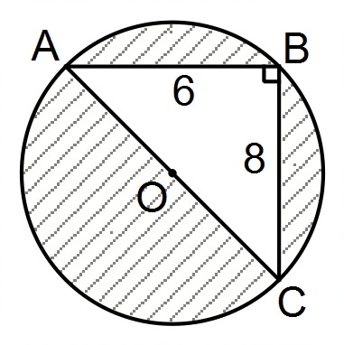

(b) This is the net of a solid cylinder, which has a radius of 6 cm.

(i) Calculate the volume of the cylinder. (2 marks)

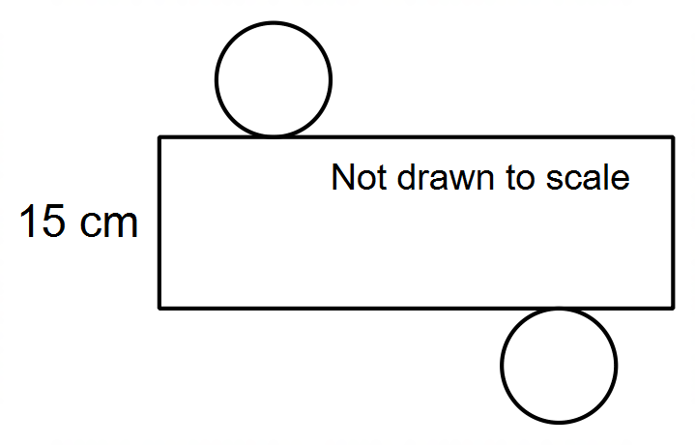

(ii) Calculate the surface area of the cylinder. (3 marks)

**Question 17 (6 marks)**

At an end of year party, some people have brought gifts to give to others.

Matrix G has that information.

|  |  |  |  |  |  |
| --- | --- | --- | --- | --- | --- |
|  |  |  |  | Has a gift for this person |  |
|  |  |  |  | A B C D |  |
|  |  | A |  | 0 1 1 1 |  |
| G = | This person | B |  | 0 0 1 0 |  |
|  |  | C |  | 1 0 0 1 |  |
|  |  | D |  | 0 0 0 0 |  |

(a) Answer the questions about information displayed in the matrix.

(i) What information is provided in Row 2 Column 1? (1 mark)

(ii) Who brought the most gifts for friends? (1 mark)

(iii) How many gifts did C receive? (1 mark)

One person received the same gift from a friend, as he gave to that friend.

(iv) Who was that person, and who was the friend? (1 mark)

(b) (i) Calculate G2. (1 mark)

(ii) What is the meaning to G2 in the context of the question? (1 mark)

**Question 18 (4 marks)**

The network below shows possible paths (two way and one way) between vertices A, B and C.

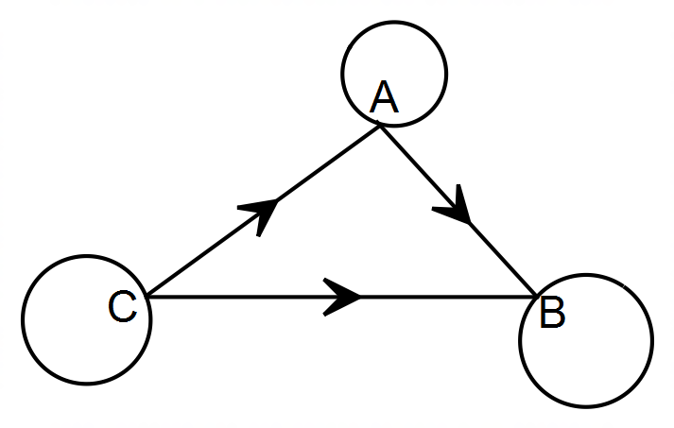

(a) Complete the matrix which represents the one stage routes shown on the network. (2 marks)

|  |  |  |  |  |  |
| --- | --- | --- | --- | --- | --- |
|  |  |  |  | To |  |
|  |  |  |  | A B C |  |
|  |  | A |  | 2 1 0 |  |
|  | From | B |  |  |  |
|  |  | C |  |  |  |

(b) Hence, or otherwise, determine the two-stage route matrix for the same network. (2 marks)

|  |  |  |  |  |  |
| --- | --- | --- | --- | --- | --- |
|  |  |  |  | To (In two stages) |  |
|  |  |  |  | A B C |  |
|  |  | A |  |  |  |
|  | From | B |  |  |  |
|  |  | C |  |  |  |

**Question 19 (3 marks)**

A packet of ten small chocolate bars, each of which weighs 20 g, costs $5.20

A chocolate slab, weighing 150 g, costs $3.80

Use the unit method to determine which is the best value for money. (3 marks)

**Question 20 (12 marks)**

A triangular region on a map has sides measuring 1 cm, 1.5 cm and 2 cm.

The scale on the map is 1:200

(a) What is the length of the longest side in the **real** region, expressed in metres?

(2 marks)

(b) Are the three angles of the triangle on the map equal to the corresponding three angles of the real triangular region? Explain. (1 mark)

(c) A nature reserve on the map is in the shape of a parallelogram, with length 4.8 cm and perpendicular height 3.5 cm. What is the area of the **real** nature reserve, in m2? (4 marks)

(d) To find the width of a river, Jordan surveys the area and finds the following measurements.

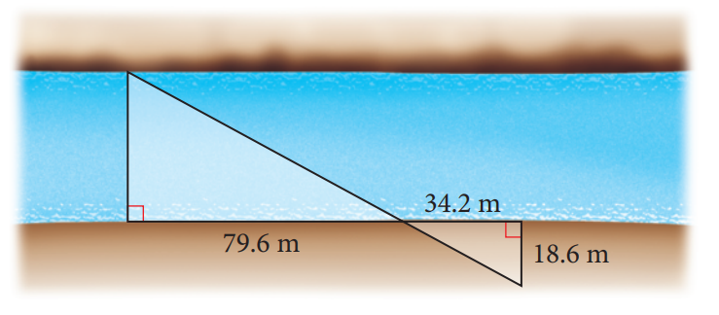

1. Explain why the two triangles are similar (2 marks)
2. Calculate the width of the river (3 marks)

**End of questions**

**Additional working space**

Question number(s): ……………………

**Additional working space**

Question number(s): ……………………

WATP acknowledges the permission of the School Curriculum and Assessment Authority in providing instructions to students.